GGN - Geopark Annual Report 2020

- GEOPARK IDENTITY
- Name, nation and area network of the Geopark: Wudalianchi UNESCO Global Geopark (China, APGN )
Year of accession/ year of re-evaluation:2004/2008/2012/2014/2018
Representative Photoes
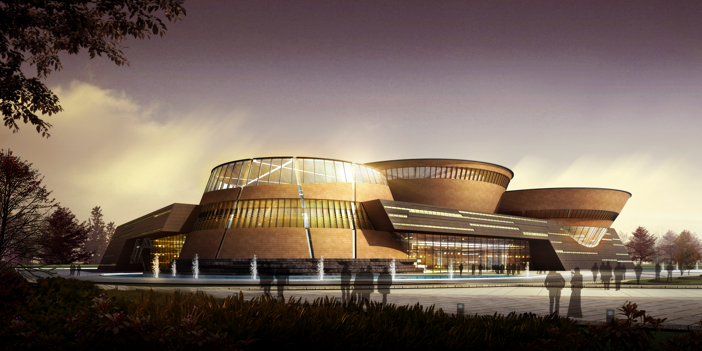
The main body of the Global Geopark museum in Wudalianchi has open to tourists.
2.GEOPARK FIGURES
Number of staff in the Geopark: 2,057
Number of tourists: totally 1.99 million person time
Number of activities: 18
Number of Geopark educational projects in school: 20
Number of publications issued by geopark: 3
Name of books published by Geopark are Come to Wudalianchi, Show You around Wudalianchi(for Children), Research in Wudalianchi.
3. GEOPARK ACTIVITIES
Main achievements in 2020
- Organized annually many activities, such as Wudalianchi Volcano Holy Water Festival, Volcano International Marathon Race and New Year Climbing, etc.;
- Cooperated with universities at home and abroad, in which students join researching studies held in the Geopark.
- Dicount tickets policies for pupils has been formulated and published by the Geopark, which encourage pupils, middle school students and college students to visit the park.
- Provided free publicity materials for teaching institutions such as poster foldout, Wudalianchi Scientific Expedition Guide and Wudalianchi Touring Guide, etc.
- Published promotion information such as pupil discount tickets through CCTV, Heihe TV, Wudalianchi Global Geopark TV and domestic magazines.
- Released preferential policies and related new of Geopark by the website of the park and cooperated organizations. Took the advantage of “Owned Media” and encourage tourists to visit and research Wudalianchi.
- Held training courses for science-tourism guides
Contribution to GGN - Network activities and Participation
- Participated in the UGGp Annual Conference in Guangwushan-Nuoshuihe;
- Chinese Volcanics ＆ Volcano Geoparks Forum was held in Yandangshan from 18th to 19th November, 2020. The representatives of Wudalianchi took part in the forum and made reports named The Value of Monogenetic Volcanoes in Unique Intracontinental Tectonics.Hexigten UNESCO Global Geopark joined in the volcano union. Wudalianchi UNESCO Global Geopark will held the next volcanics and volcano forum in 2022.
Management and financial status
- Management body: Wudalianchi UNESCO Global Geopark Administration Committee
- Financial status: The Geopark achieved a good balance of payments and financial stability. In 2020, the Geopark received tourists 1,990,000 person times and tourism revenue reached 0.695 billion yuan, increasing by 9 percent and 4 percent respectly.
Geoconservation
- Invested 980 thousand Yuan in mending the dangerous Jiangjun Rock in Laohei Volcano;
- Finished the outdoor investigation of the first section of Geo-heritage Conservation Projects(year 2015 and the second phrase of year 2014) in Wudalianchi Global Geopark. Now the equipment is being installed and the report is being prepared.
- Upgraded roads and bridges in the Geopark;
- Prepared the reformation programme for the Wudalianchi National Nature Reserve, and now the programme is reported to National Forestry and Grassland Administration for approval.
- Prepared the work for geologic hazard provention;
Sustainable tourism (geotourism)
A great number of geotourism activities were offered to visitors, such as visiting museums, Laohei Volcano Area, medicine springs tours, Wenpo Lake Area, Longmen Stone Village Area, Crystal Cave sightseeing, White Dragon Cave sightseeing and volcanic barrier lakes sightseeing, musical drama, etc.
New educational plans for geoheritage conservation, sustainable development and disaster risk reduction
The Geopark cooperated with Wudalianchi senior middle school, Wudalianchi junior middle school, Wudalianchi No. 1st primary school and No., 2nd primary school on giving “Science Knowledge Courses” and completing science popularization textbook “Close to Nature-Approaching Wudalianchi”. There are 10 parts in the textbook and 1033 students joint the 16 class hours.
Strategic partners
- Cooperated with Wudalianchi Volcano and Earthquake Monitoring Station on the study of Wudalianchi Volcanic Cluster deep structure and activity.
- Worked with Heilongjiang Hydrogeology and Engineering Geology Survey Bureau on studying the water and soil interaction in Micro-environment of Wudalianchi mineral water area.
- Employed Beijing Fanhua Group for planing the development of the Geopark.
- Worked with UNESCO-HIST, collecting dates of the climate changes and natural disasters timely, and detecting the area by satellite in the sky.
- Geopark and China Geological Survey Bureau Nanjing Center promoted the repair project of Outdoor Tourism Interpretation System and added more display contents and designed projects in the Wudalianchi Global Geopark museum exhibitions together.
- The Geopark carried out scientific research with University of Science and Technology of China, China University of Geosciences (Beijing), Jilin University, Heilongjiang Institute of Technology, Heilongjiang University, Northeast Forestry University and Heilongjiang Hydrogeology and Engineering Geology Survey Bureau.

Promotion activities
The Geopark has promoted Wudalianchi ads. on CCTV radio, Heilongjiang TV station, mainstream media, newspapers and periodicals all the year round.
4. Contacts:
Manager: Liu Yang, Email: wdlcggp@163.com
Geologists: Liu Jiaqi, Academician, Chinese Academy of Sciences;
Zhang Haiyan, Deputy Chief Engineer, Hydrogeological Engineering Geological Survey of Heilongjiang Province

